Inverter layout

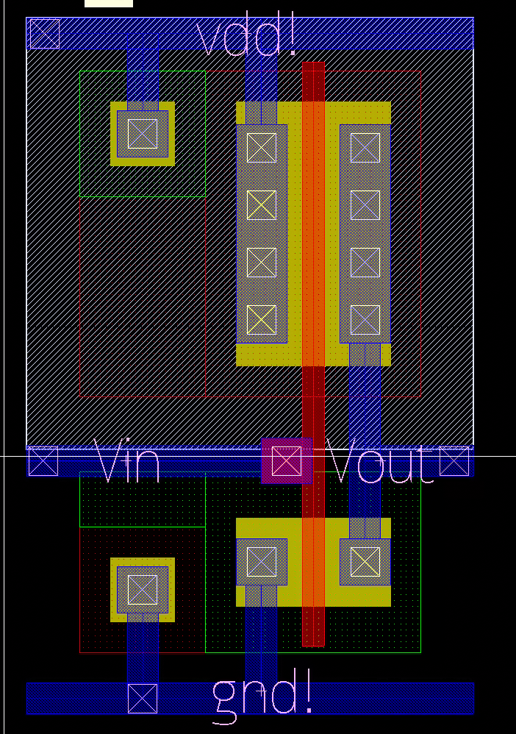

DRC Clean

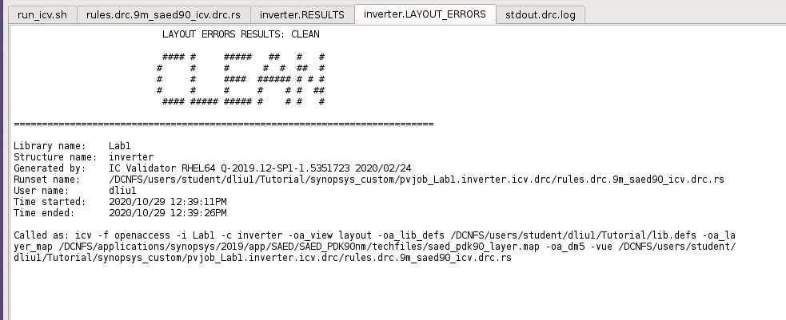

Question 1

* NWELL: N-Well
* DIFF: Diffusion
* PIMP: P+ Implantation
* NIMP: N+ Implantation
* PO: Polysilicon
* M1: Metal 1

Question 2

PMOS Width: X-Axis: 0.1 um

PMOS Length: Y-Axis: 1.48 um

NMOS Width: X-Axis: 0.1 um

NMOS Length: Y-Axis: 0.82 um

Conclusion:

NIMP layers are used for NMOS and PIMP layers are used for PMOS. Both the PMOS and NMOS have the same channel width, but different channel lengths.